**LEBANESE AMERICAN UNIVERSITY**

**USAID – HIGHER EDUCATION SCHOLARSHIP PROGRAM**

**HES - Volunteering Program Verification Form**

This form is to be used to document volunteering hours. If a student volunteers for multiple organizations, a separate form must be used for each organization. **This form must be turned in by the 28th of each month, the latest.**

I certify that the scholar Amal ALRajab completed a total of 5 hours of service at InnovaThrive.

The hours were completed hours as per the below:

Hours # 1 (date) _2/12 – 6/12_ (initials of supervisor) __A.K.___

Hours # 1 (date) _9/12 – 13/12_ (initials of supervisor) __A.K.___

Hours # 2 date) _16/12 – 20/12 (initials of supervisor) __A.K.___

Hours # 1 date) _23/12 - 27/12 (initials of supervisor) __A.K.___

Brief description of the activities the scholar performed or participated in:

I conducted research on The Influence of Cultural Factors on Consumer Behavior, exploring how cultural elements shape purchasing decisions and consumer preferences. My study examined various cultural aspects, such as traditions, social norms, and values, and their impact on brand perception, product choice, and marketing strategies. I analyzed case studies and statistical data to highlight key insights into cross-cultural consumer behavior and the importance of cultural awareness in global marketing. Additionally, I explored both the advantages and challenges businesses face in addressing cultural diversity, such as the need for localized marketing strategies and the difficulty of managing global brand consistency. Finally, I suggested areas for future research, including the influence of digital culture and social media trends on consumer behavior across different regions and demographics.

Written feedback about the scholar’s performance:

Amal showcased strong research and analytical skills by examining cultural factors in consumer behavior, providing actionable insights into global marketing strategies and cross-cultural dynamics.

Please rate the overall performance of the scholar at your organization:

|  |  |  |  |
| --- | --- | --- | --- |
|  | Mastery (5) | Proficient (3) | Emerging (1) |
| **Problem solver** | X |  |  |
| **Engaged & Committed** | X |  |  |
| **Open-minded & multicultural** | X |  |  |

Signature

& stamp

__________________________

_

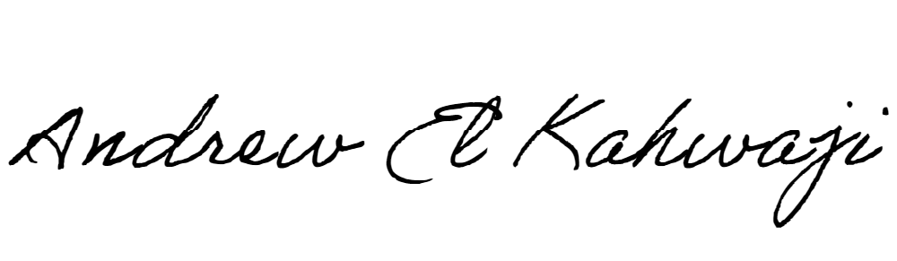

Printed Name _Andrew El Kahwaji_

Date __26/12/2024___

Email __andrew.lifesculptor.coo@gmail.com __

Phone __+961 71 914 378__